

**King Fahd University of Petroleum and Minerals**

**Information and Computer Science Department**

**ICS 324**

**Term 143**

**Phase 1: Conceptual and Logical Design**

|  |  |
| --- | --- |
| Member | ID |
| Ibrahim BinAlshikh | 201139750 |
| Ibrahim | 201224780 |
| Aqeel | 201236760 |

Table of Contents

1. Problem Statement 2

2. Assumptions 2

3. Database Requirements (defines the entities, attributes, relationships and constraints). 2

4. Conceptual schema (ER/EER Model) 3

5. Relational schema (all relations and constraints) 3

6. DDL statements to create database tables 4

# Problem Statement

We have to design and implement a database that can be used by academic institutions to record the grades of students in specific course. To design this, we have to consider 3 main actors: student, instructor and a course. Each of those will affect the final product.

# Assumptions

* 1. We will assume that the database will be made for KFUPM use.
  2. We will assume that the length of names will not exceed 15 characters.
  3. We will assume that the condition for most relations on delete will be ‘set null’.
  4. When a section is removed, all students will be removed from that section.
  5. Assume that each course will have at least 2 grading component.
  6. Assume that the number of grading component for all courses won’t exceed 1000.
  7. Assume that each college and department has an alphabetic unique ID that represents it.
  8. Assume that the section reference number will be formed as follows: College ID + Department ID + course number + section number + term number(e.g. AA1111-53-1)
  9. Assume that every year the section reference number is recycled.
  10. Each section will be taught by one instructor.
  11. Assume that the sum of all points on a section can be less than 100 or more.

# Database Requirements (defines the entities, attributes, relationships and constraints).

We can summarize the database requirements as follows:

1. Students’ first and last names and majors shall be recorded and be identified with a unique student id
2. Courses’ number shall be recorded and it shall be identified with a unique course id
3. Each section must belong to a course in a specific term and shall be identified by a unique section number and taught by an instructor
4. The section is made up from several grading components where each has a maximum points and an overall weight
5. Sections must have enrolled students
6. The instructor will be able to record points for students
7. Instructors shall be able to assign letter grades and grade cutoffs for each of his section

# Conceptual schema (ER/EER Model)

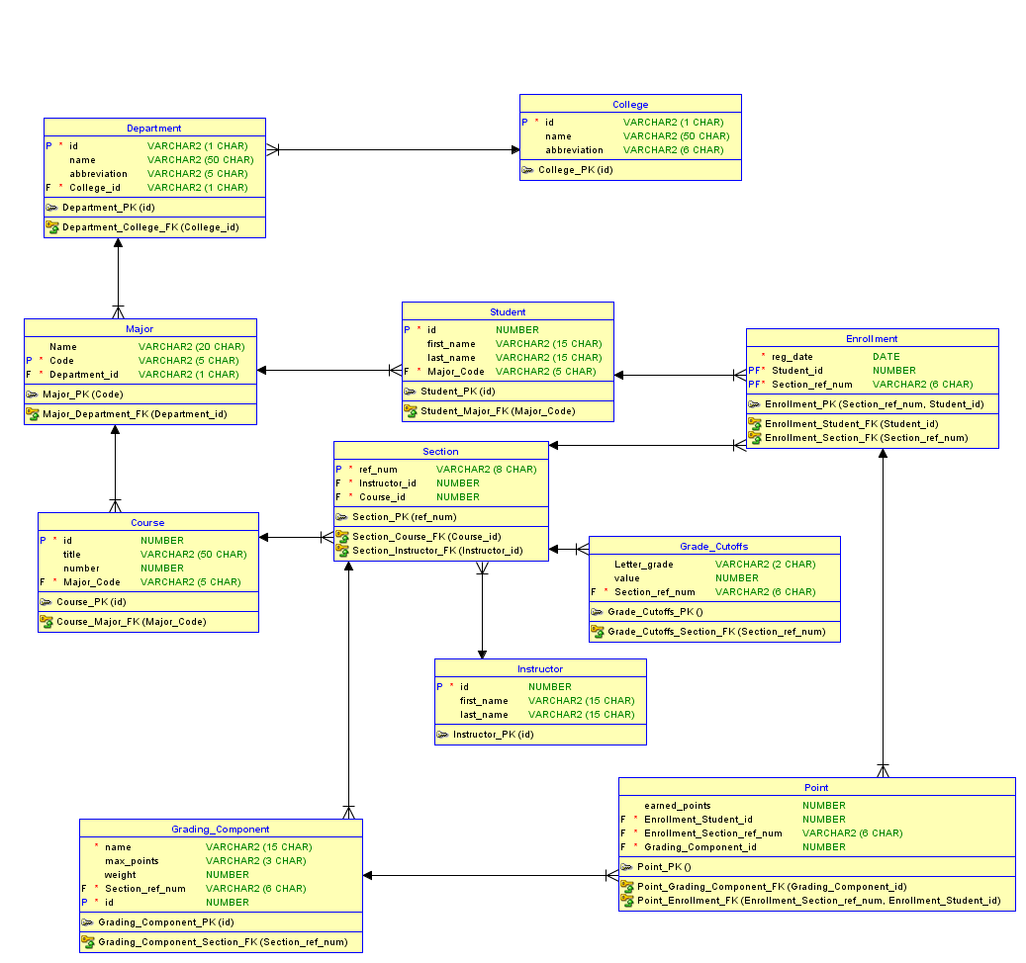

# Relational schema (all relations and constraints)

# DDL statements to create database tables

-- Generated by Oracle SQL Developer Data Modeler 4.1.1.888

-- at: 2015-08-03 23:37:09 AST

-- site: Oracle Database 12c

-- type: Oracle Database 12c

CREATE TABLE College

(

id VARCHAR(1) NOT NULL ,

name VARCHAR (50) ,

abbreviation VARCHAR(5)

) ;

ALTER TABLE College ADD CONSTRAINT College_PK PRIMARY KEY ( id ) ;

CREATE TABLE Course

(

"number" numeric(4) NOT NULL ,

title VARCHAR (50) ,

"level" numeric(3) ,

Major_code VARCHAR (4) NOT NULL

) ;

ALTER TABLE Course ADD CONSTRAINT Course_PK PRIMARY KEY ( "number" ) ;

CREATE TABLE Department

(

id VARCHAR (1) NOT NULL ,

name VARCHAR (50) ,

abbreviation VARCHAR (5 ) ,

College_id VARCHAR (1 ) NOT NULL

) ;

ALTER TABLE Department ADD CONSTRAINT Department_PK PRIMARY KEY ( id ) ;

CREATE TABLE Enrollment

(

reg_date DATE ,

Student_id numeric(9) NOT NULL ,

Section_refrence_number VARCHAR (11) NOT NULL

) ;

ALTER TABLE Enrollment ADD CONSTRAINT Enrollment_PK PRIMARY KEY ( Student_id, Section_refrence_number ) ;

CREATE TABLE Grading_Component

(

id numeric(3) NOT NULL ,

name VARCHAR (15) ,

max_points numeric(3) ,

weight numeric(2) ,

Course_number numeric(4) NOT NULL ,

Instructor_id numeric(9) NOT NULL

) ;

ALTER TABLE Grading_Component ADD CONSTRAINT Grading_Component_PK PRIMARY KEY ( id ) ;

CREATE TABLE Instructor

(

id numeric(9) NOT NULL ,

first_name VARCHAR (15) ,

last_name VARCHAR (15)

) ;

ALTER TABLE Instructor ADD CONSTRAINT Instructor_PK PRIMARY KEY ( id ) ;

CREATE TABLE Major

(

name VARCHAR(50) ,

code VARCHAR(4) NOT NULL ,

Department_id VARCHAR (1) NOT NULL

) ;

ALTER TABLE Major ADD CONSTRAINT Major_PK PRIMARY KEY ( code ) ;

CREATE TABLE Point

(

earned_Points numeric(3) ,

Grading_Component_id numeric(3) NOT NULL ,

Enrollment_Student_id numeric(9) NOT NULL ,

Enrollment_refrence_number VARCHAR (11) NOT NULL

) ;

CREATE TABLE Section

(

refrence_number VARCHAR (11) NOT NULL ,

"number" numeric(2) ,

Instructor_id numeric(9) NOT NULL

) ;

ALTER TABLE Section ADD CONSTRAINT Section_PK PRIMARY KEY ( refrence_number ) ;

CREATE TABLE Student

(

id numeric(9) NOT NULL ,

first_name VARCHAR (15) ,

last_name VARCHAR (15) ,

Major_code VARCHAR (4) NOT NULL

) ;

ALTER TABLE Student ADD CONSTRAINT Student_PK PRIMARY KEY ( id ) ;

ALTER TABLE Course ADD CONSTRAINT Course_Major_FK FOREIGN KEY ( Major_code ) REFERENCES Major ( code ) ON

DELETE CASCADE ;

ALTER TABLE Department ADD CONSTRAINT Department_College_FK FOREIGN KEY ( College_id ) REFERENCES College ( id ) ;

ALTER TABLE Enrollment ADD CONSTRAINT Enroll_Section_FK FOREIGN KEY ( Section_refrence_number ) REFERENCES Section ( refrence_number ) ON

DELETE CASCADE ;

ALTER TABLE Enrollment ADD CONSTRAINT Enroll_Student_FK FOREIGN KEY ( Student_id ) REFERENCES Student ( id ) ;

ALTER TABLE Grading_Component ADD CONSTRAINT Grading_Comp_Course_FK FOREIGN KEY ( Course_number ) REFERENCES Course ( "number" ) ON

DELETE CASCADE ;

ALTER TABLE Grading_Component ADD CONSTRAINT Grading_Comp_Inst_FK FOREIGN KEY ( Instructor_id ) REFERENCES Instructor ( id ) ON

DELETE CASCADE ;

ALTER TABLE Major ADD CONSTRAINT Major_Department_FK FOREIGN KEY ( Department_id ) REFERENCES Department ( id ) ;

ALTER TABLE Point ADD CONSTRAINT Point_Enrollment_FK FOREIGN KEY ( Enrollment_Student_id, Enrollment_refrence_number ) REFERENCES Enrollment ( Student_id, Section_refrence_number ) ON

DELETE CASCADE ;

ALTER TABLE Point ADD CONSTRAINT Point_Grading_Comp_FK FOREIGN KEY ( Grading_Component_id ) REFERENCES Grading_Component ( id ) ON

DELETE CASCADE ;

ALTER TABLE Section ADD CONSTRAINT Section_Instructor_FK FOREIGN KEY ( Instructor_id ) REFERENCES Instructor ( id ) ;

ALTER TABLE Student ADD CONSTRAINT Student_Major_FK FOREIGN KEY ( Major_code ) REFERENCES Major ( code ) ;